SALARY PREDICTION APP

<https://youtu.be/wlB7fkxQtoc?si=APFmJ8GME3ltYlOq>

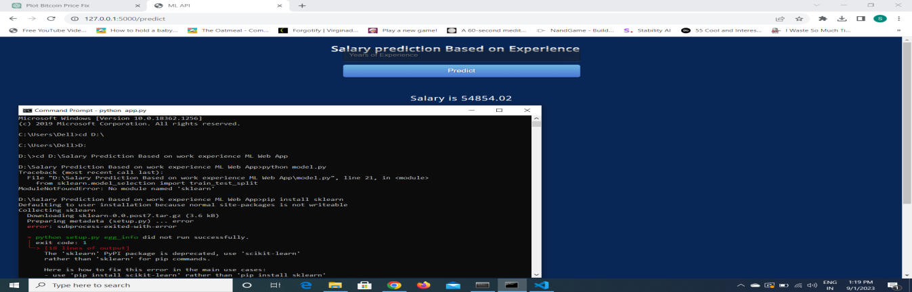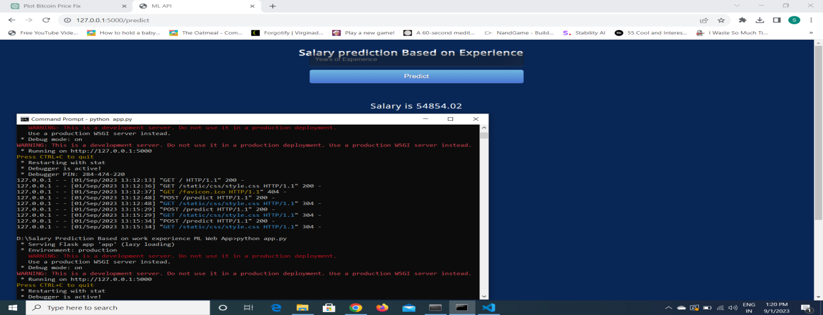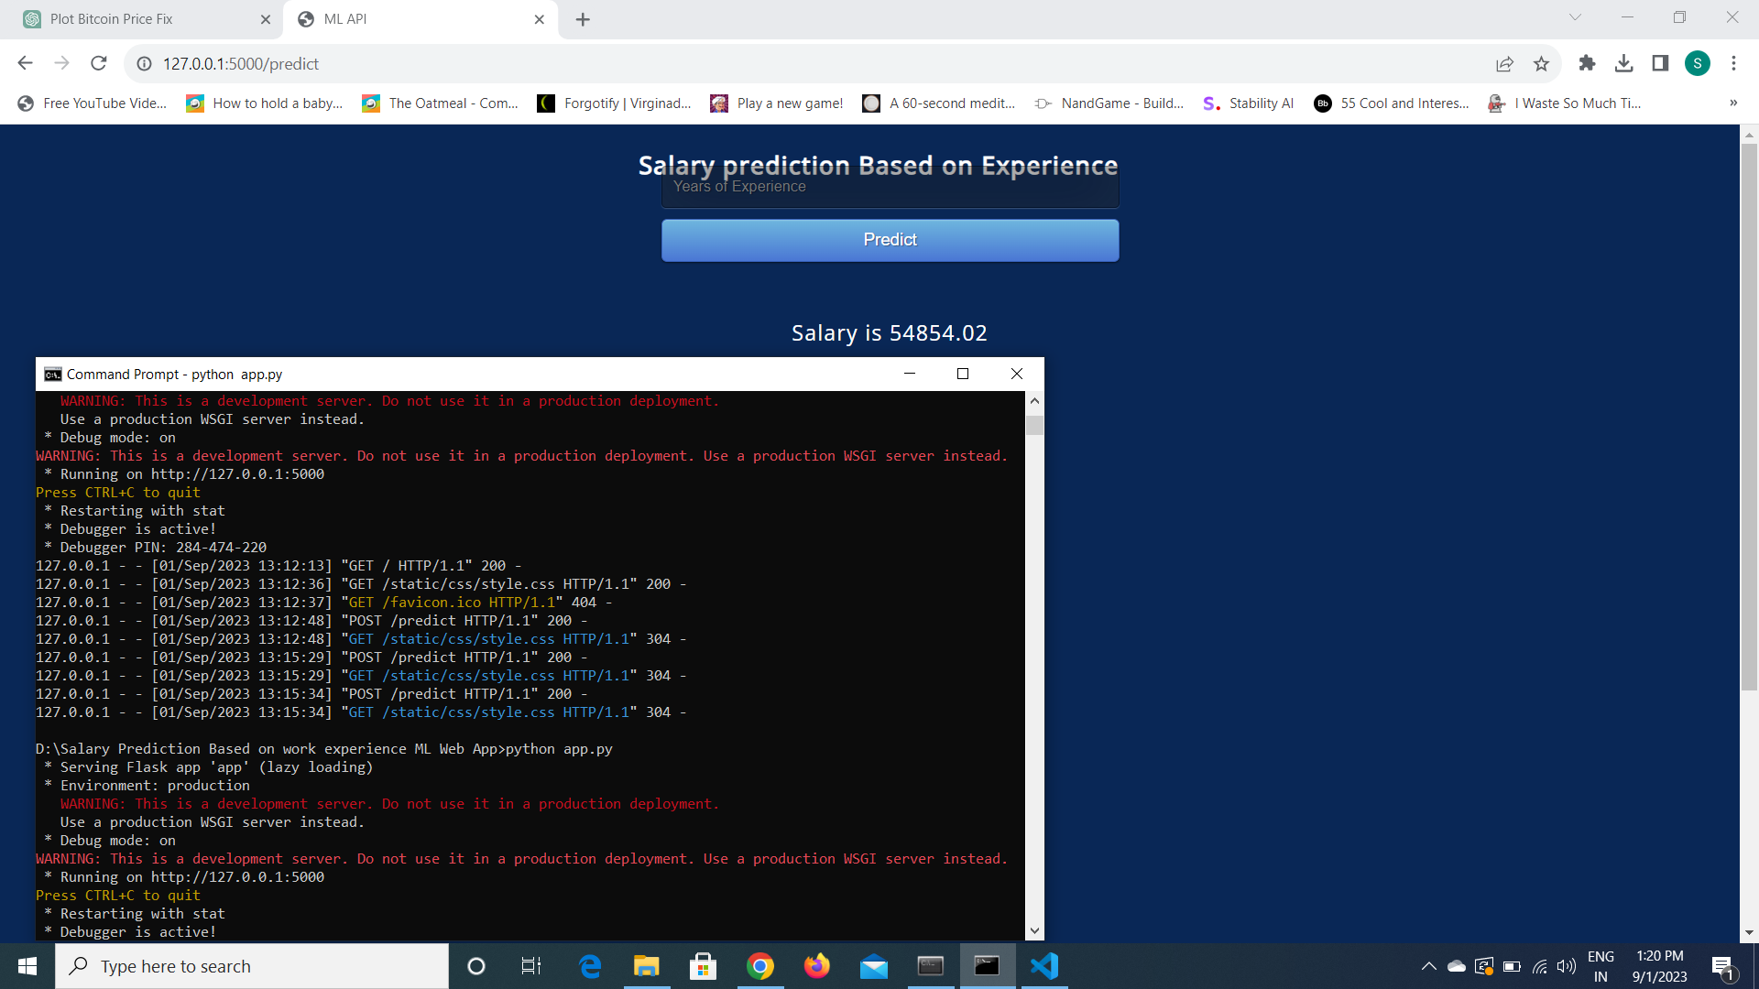

[LINK TO FOLDER](../Salary%20Prediction%20Based%20on%20work%20experience%20ML%20Web%20App)

Commands

$cd Foler Location

$python model.py

$python App.py